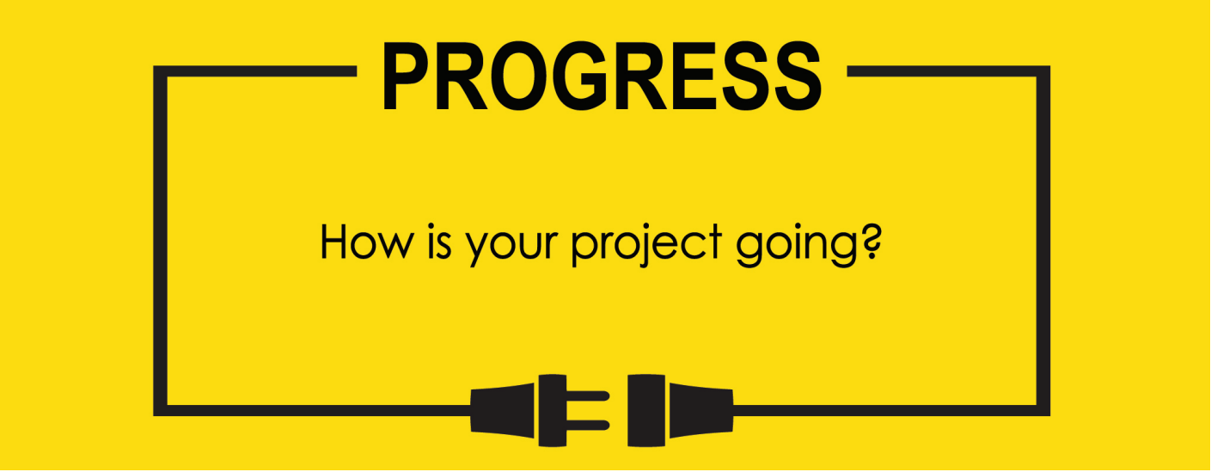

**Name: Zach Wilcox**

**Project Title: GreenBox**

**Previous Goals**

What were your three goals from last week? Were you able to complete them? If so, select Completed. If not, select the level of completion and explain in the Notes section why the goal was not completed, what still remains to be done, and when you expect to finish work on the goal.

Goal #1 from last week: Finish box build

**Status:** _____Completed ___x__Partially Completed _____No Progress

**Notes:**

Front door/hinges have been assembled.

Goal #2 Begin build on custom wicking humidifier

**Status:** _____Completed ___x__Partially Completed _____No Progress

**Notes:**

Filter itself and fan portion have been assembled. Water container and appropriate attaching pieces still need to be made.

Goal #3 from last week: Begin output for GPIO code

**Status:** _____Completed __x___Partially Completed _____No Progress

**Notes:**

Much of the output code is dependent on the input from the sensor, so sensor initialization has been done. Minor parts of GPIO output and initialization have been completed.

**Next Three Goals**

Choose three subtasks from your Gantt chart and use them to form goals that you plan to complete this week. In the text box beneath each goal, give details about what you plan to accomplish. Include details such as what materials are needed, how many hours each day you plan to devote to the task, and so on.

NOTE: THESE ARE INDIVIDUAL GOALS THAT YOU PLAN TO ACCOMPLISH. THESE ARE NOT TEAM GOALS.

**Goal #1:** Finish box build

**Goal #2:** Finish sensor input code

**Goal #3:** Finish GPIO output code

Humidity and Temperature sensor code.

Old Gantt chart

Box assembly extended, hardware interfacing extended, final assembly pushed back.